Problem 23 - B
Divisible group sums

Given an array of n integers, an integer k, 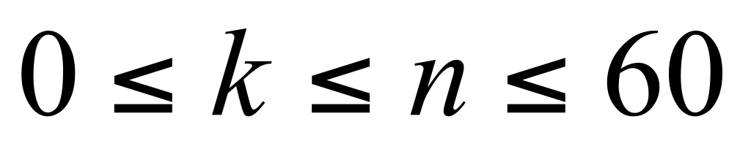, and an integer d, 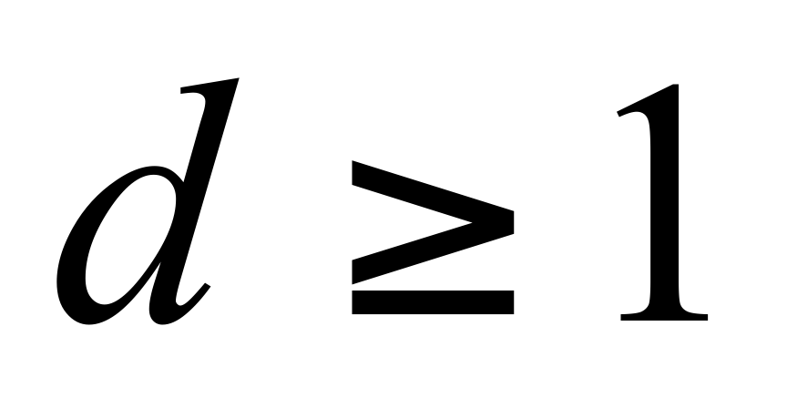. For all groups of k integers chosen from the array, determine how many of these chosen groups have a sum, which is divisible by d.

Input
The first line of input file contains an integer number M specifying the number of test cases. Each test case consists of a single line. In the beginning of test case are 3 decimal numbers indicating (n, k, d). Following the 3 decimal numbers is the array of n integers. All numbers in the same line are interleaved by a space.

Output
The output data file contains M lines, each of which is the number of groups for the corresponding input case. For the i-th case, you should output Case i: followed by a space and the number of groups in line i.

Sample Input
3
7 2 5 1 3 5 6 7 8 9
7 5 3 1 3 5 6 7 8 9
7 6 7 1 3 5 6 7 8 9

Sample Output for the Sample Input
Case 1: 4
Case 2: 7
Case 3: 0

All inputs are from stdin and outputs to stdout.

